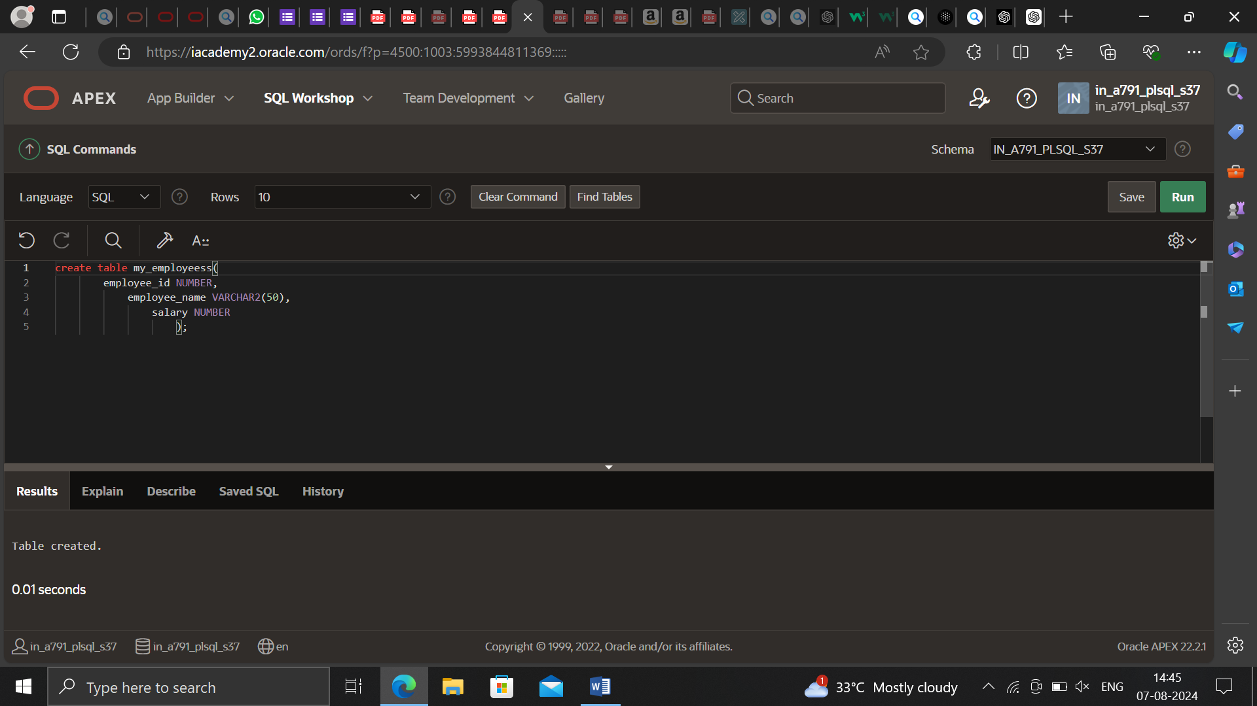

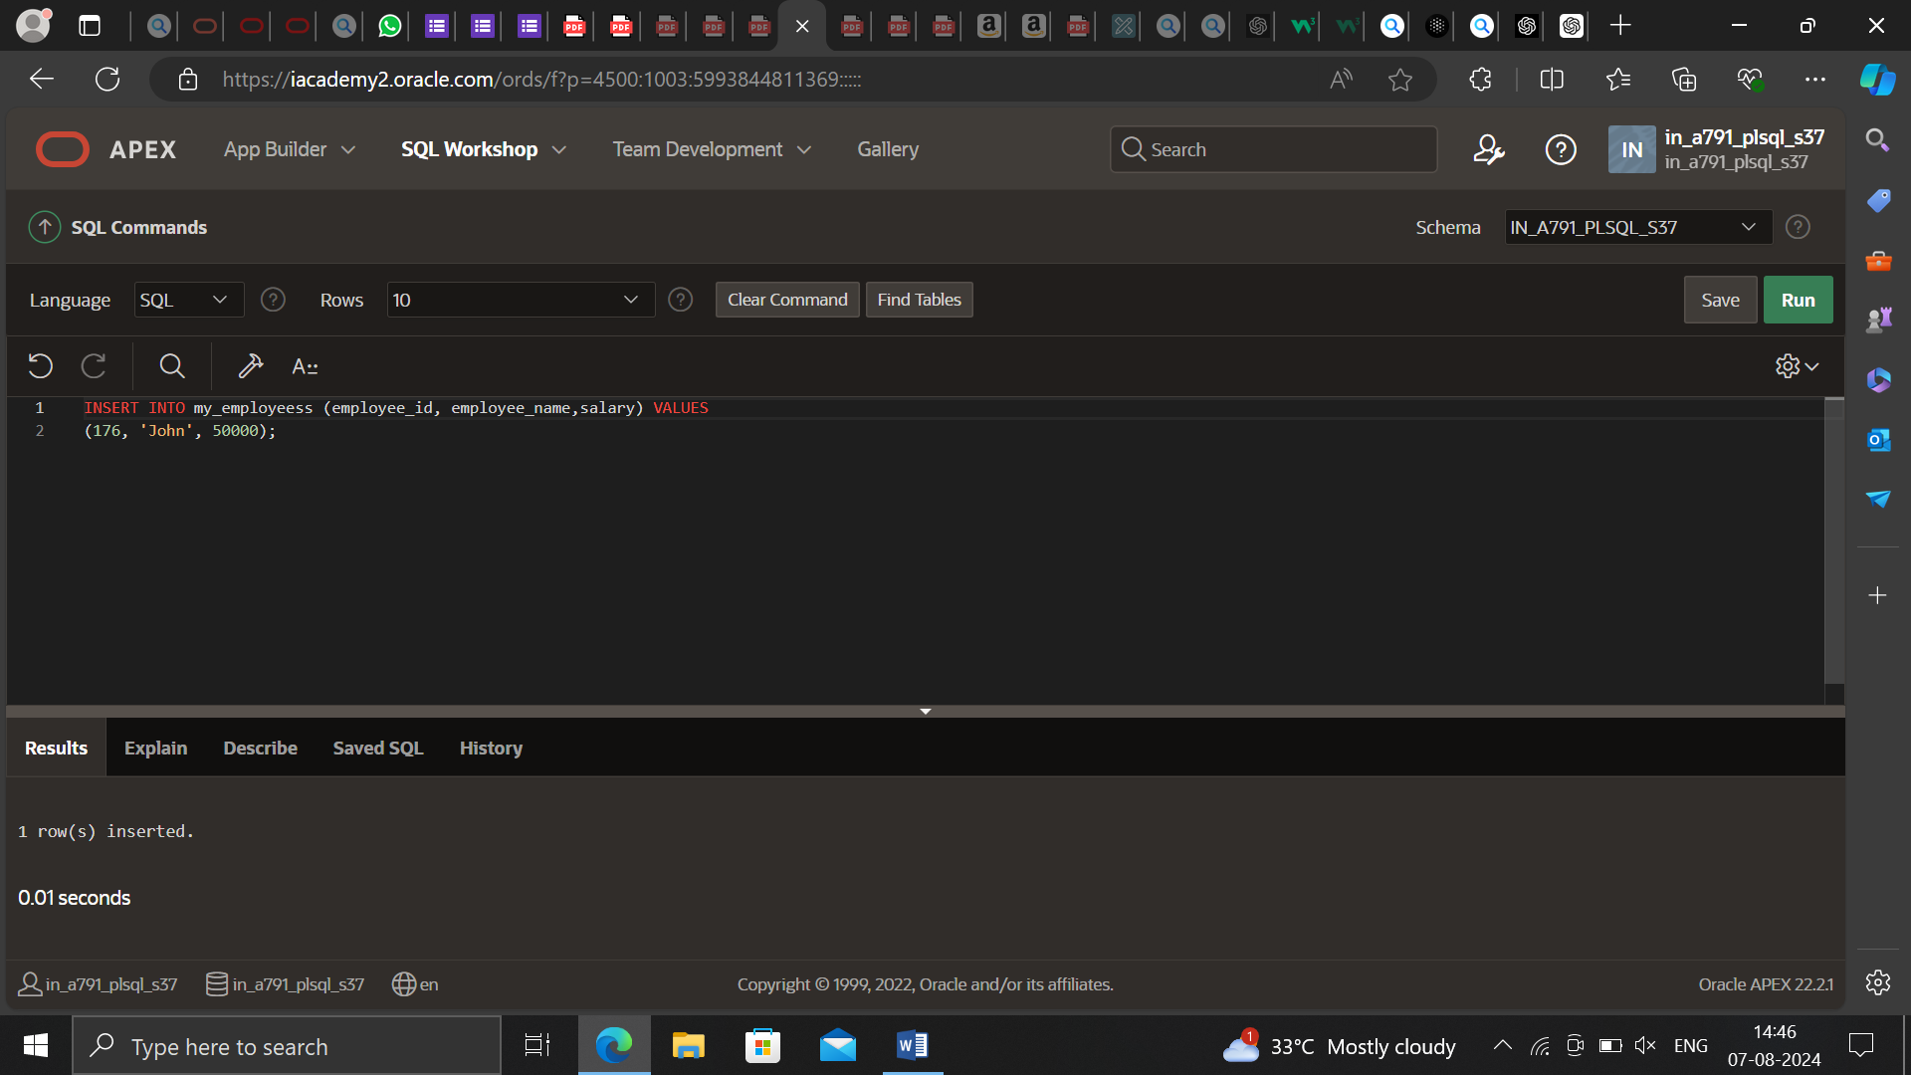

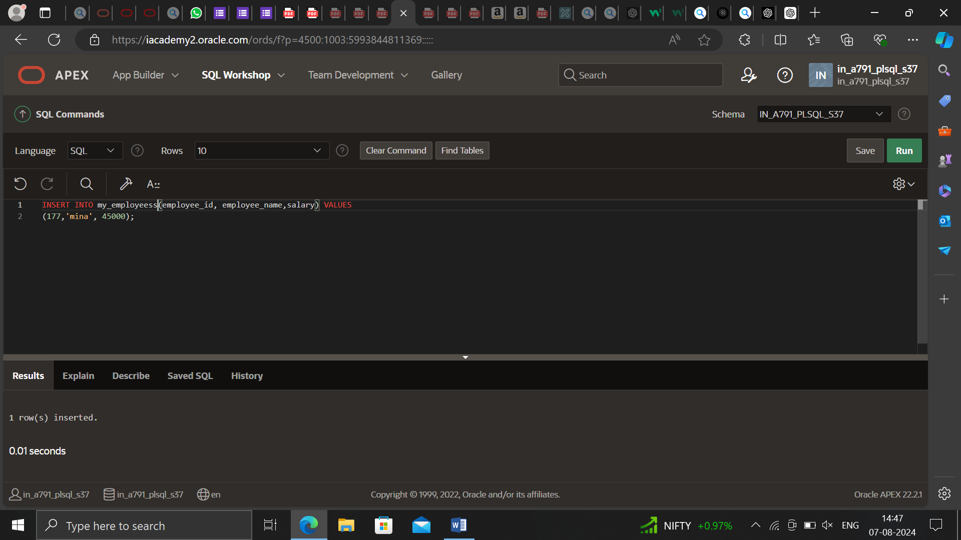

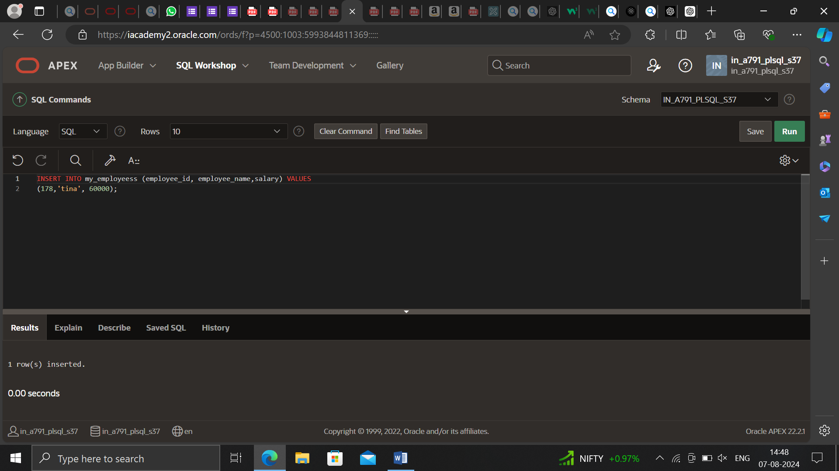

CREATE OR REPLACE PROCEDURE raise_salary

(p_id IN my_employees.employee_id%TYPE,

p_percent IN NUMBER)

IS

BEGIN

UPDATE my_employees

SET salary = salary * (1 + p_percent/100)

WHERE employee_id = p_id;

END raise_salary;

BEGIN raise_salary(176, 10); END;

